الجمهورية اللبنانية
الاسم والشهرة:--------------------
رقم المرشح :----------------------
وزارة التربية والتعليم العالي الامتحانات الرسمية لشهادة الامتياز الفني
المديرية العامة للتعليم المهني والتقني لدورة عام 2021 الأولى
=================
الإختصاص والرمز : المعلوماتية الادارية (23104)
المادة : برمجة ويب Web المعدل : (10 )
المستندات المسموح بها: لا شيء المدة : ساعتان
الإجابات على "كراس الإجابة"

Treat the following questions:
- Choose the correct answer: (1 pt / correct answer)
- Which attribute tells the browser where to go when a hyperlink is clicked?
- src
- url
- href
- If we want to wrap a block of text around an image, which CSS property will we use ?
- wrap
- align
- float
- If we want to use a nice looking green dotted border around an image, which CSS property will we use?
- border-color
- border-decoration
- border-style
- What is the correct HTML for inserting an image?
- <image src="image.gif" alt="MyImage">
- <img src="image.gif" alt="MyImage">
- <img href="image.gif" alt="MyImage">
- The attribute (s) of <form> tag is:
- Method
- Action
- Both (a) and (b)
- <DT> tag is designed to fit a single line of our web page but <DD> tag will accept a:
- A line of text
- A full paragraph
- A word
- How can you open a link in a new browser window?
- < a href = "url" target = "new">
- <a href = "url" target= "_blank">
- <a href = "url" target ="open">
- <INPUT> is an :
- Empty tag
- Format tag
- Both (a) and (b)
- Which of the following CSS property is used to set the text formatting?
- Font
- Text-decoration
- Font-style
- What will happen if height and width of video are not set while video loads?
- The page flickers
- The page does not load
- The page crash

- Write the appropriate HTML5 tags and the appropriate CSS properties to obtain as result the following page: ( 3 pts)
The page has the following properties:

Background color: gray (#dddddd).

The first paragraph has the following properties: font size:18 color: black Times new roman
Rounded borders: 20 pixels. Background color: white. Text aligned at the right.

The second paragraph has the following properties:
Rounded borders: 20 pixels. Background color: white. Text align at the left.

The third paragraph has the following properties:
Border: 2 pixels Border style: « dashed » Text aligned at the center.

HTML: is a link towards the page: « Learn web .html »
CSS is a link towards the web site: « CSS.com »

الإختصاص والرمز : المعلوماتية الادارية (23104)
المادة : برمجة ويب Web

Delidded Web Design
First site: build in 2019 and include
- Audio
- Video
- Photo
- Text
Making great sites since: 2018

Our services
HTML
CSS
And JavaScript programming^{@2021}

- Write the appropriate HTML5 tags and CSS properties to obtain as result the following page: ( 3 pts)

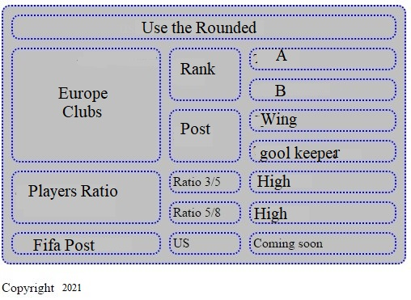  Copyright²⁰²¹ | - The table title is: "Copyright²⁰²¹", the title size is: 20 pixels aligned at the left bottom of the table.  - The table has the following characteristics:  Width: 500 pixels; Height: 50 pixels; Space between borders: 10 pixels; Round borders: 10 pixels; Background: grey.  - The table and the cells border thickness is 2 pixels, the color of the border is blue.  - Keep the table format.  - "Fifa Post" is a link towards the web site: "www.Fifa.com"

- Write the appropriate HTML5 tags to obtain the following page : (4 pts)

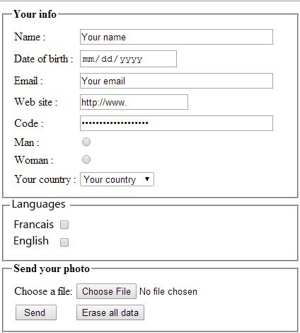 | - Name: Input field, 40 visible characters, and maximum 256 characters.  - Indicate the appropriate type for each of the following fields: Date of birth, Email, Web site, Code.  - Man / Woman: Radio button which only one choice is acceptable.  - Your country: A list box that contains the following values : "France, Canada, Lebanon, Others"  - Francais / English: Checkbox, many choices are acceptable.  - Choose a file: Input field of type file.  - Send a button to send data towards: www.mysite.com/select.php  using the post method.  - A button Erase all data to reset all values.

